**SUPPLEMENTARY FIGURE S3: comprehensive Regional Outcome heatmap**

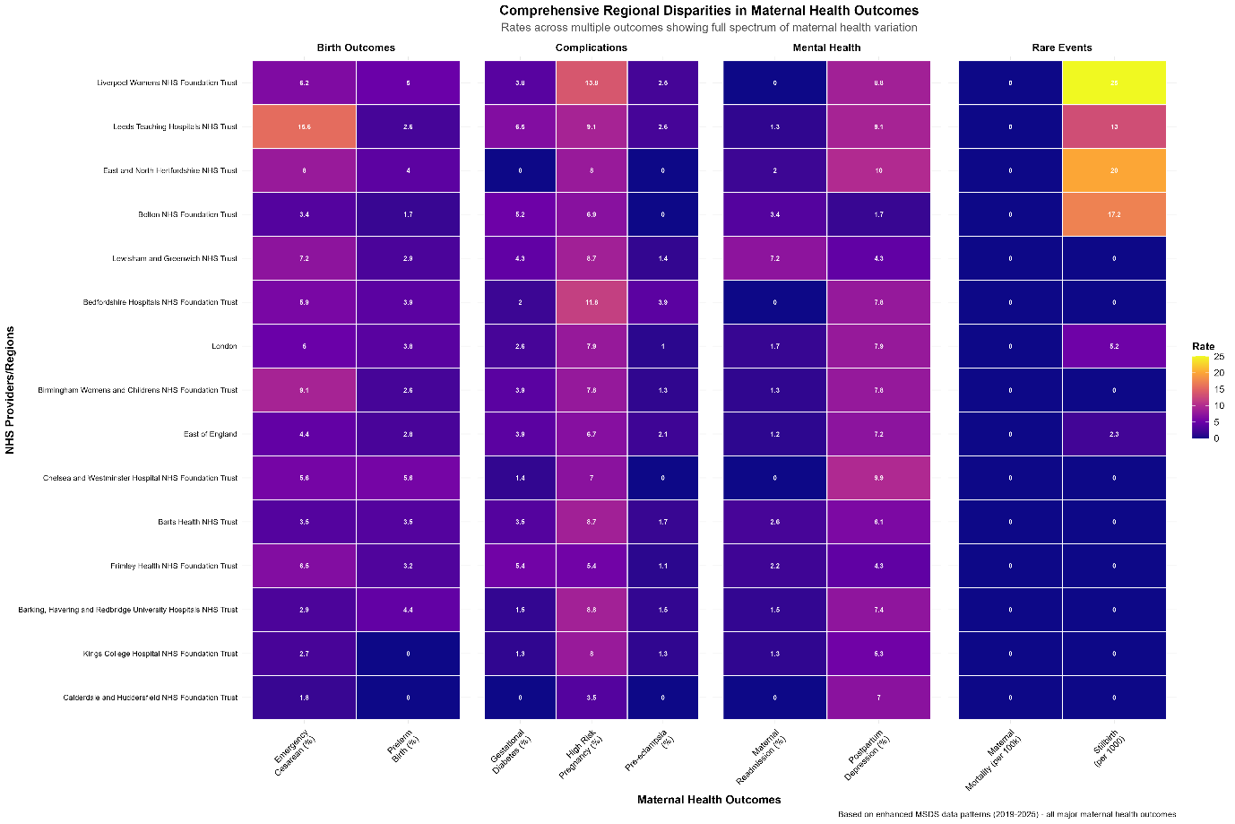

Comprehensive maternal health outcome rates across NHS provider regions showing full spectrum of variation. Heatmap displays birth outcomes, complications, mental health, and rare events across 15 NHS Foundation Trusts. Rates standardised per 1,00 births.